**Title:** Earthquake

**Name:** Mukesh Yadav Pyatla

**STD-ID:** 12599765

**Project Description:**

The goal of this project is to simulate an earthquake in a scene that includes a virtual city with cars, buildings, and roads. I'll use a grid to create roads and the box tool to make buildings. To make the earthquake look real, I'll use special tools like the RBD bullet solver for making things move realistically and material fracture for showing things breaking apart. For making the cars I will be using animation functions for the sphere-shaped tires to make them move on the road i.e., grid. I'll try to use lots of different tools we learned about in class to make the scene look detailed and lifelike. Using various tools, I will be creating various objects in the scene to give the scene more realistic and detailed view.

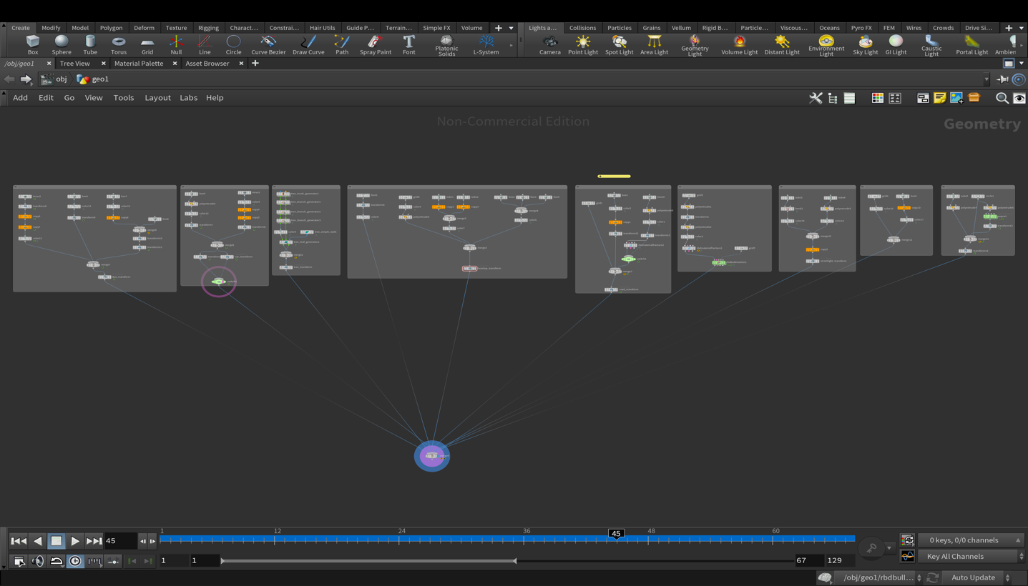

The image above depicts the complete outline of the nodes which are used in making this project.

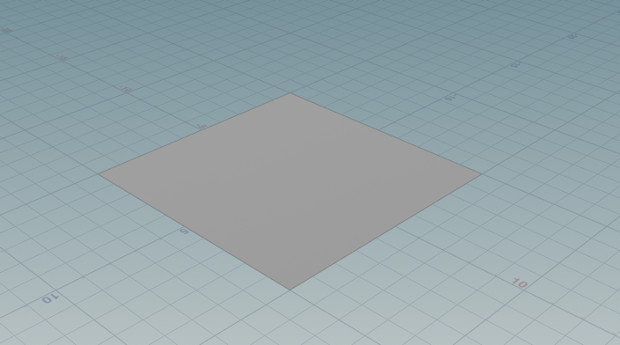Let’s dive into the deeper understanding of how it is made by categories. Firstly Let’s start creating the scene with the base as a grid. Create the orientation as ZX plane and size as 10, 10 with rows and columns as 2.

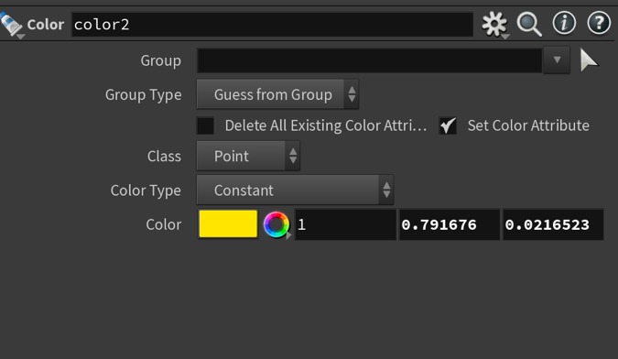Next, create a box for the road divisions(box1 node) , color node(color2) and Copy to points node(copy1) for multiple box as a complete divisions of the road with the change in parameters as below :

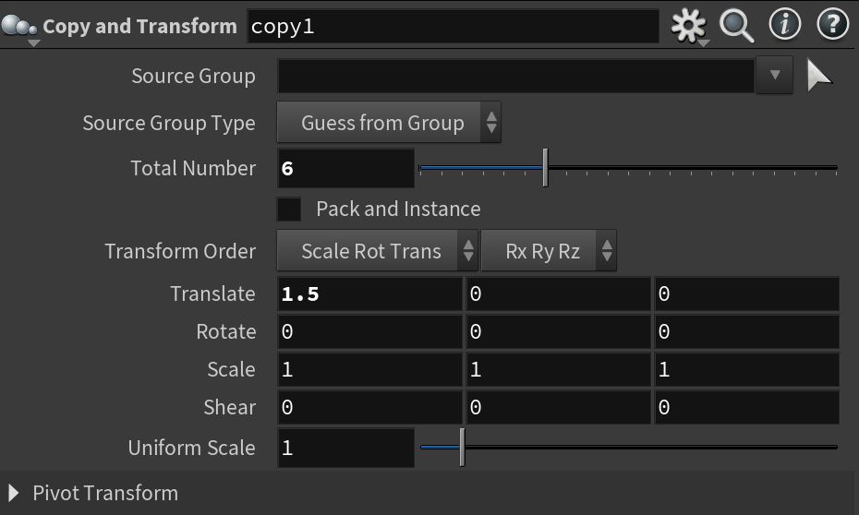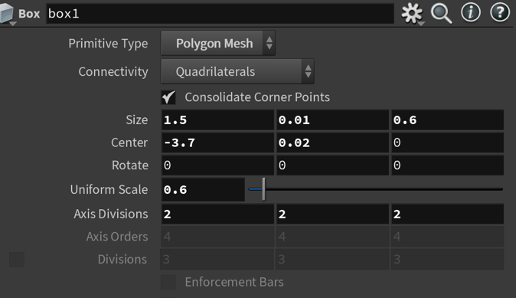Figure: Box Node as Box1 Figure: Color node

Figure: Copy and Transform Node

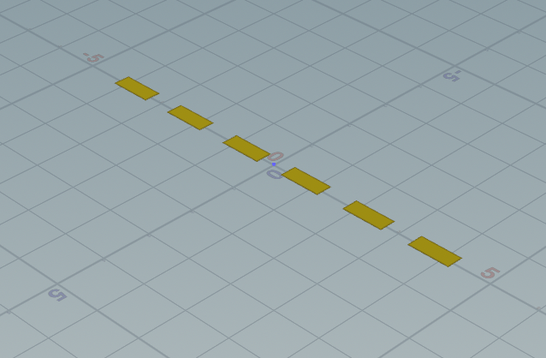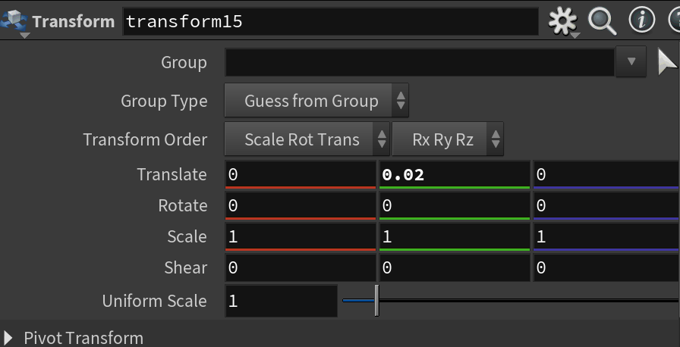This results the following road divisions and after using using transform node(transform15) with change in below parameters the output looks like as below:

Figure: Transform node Figure : Image of Road Divisons

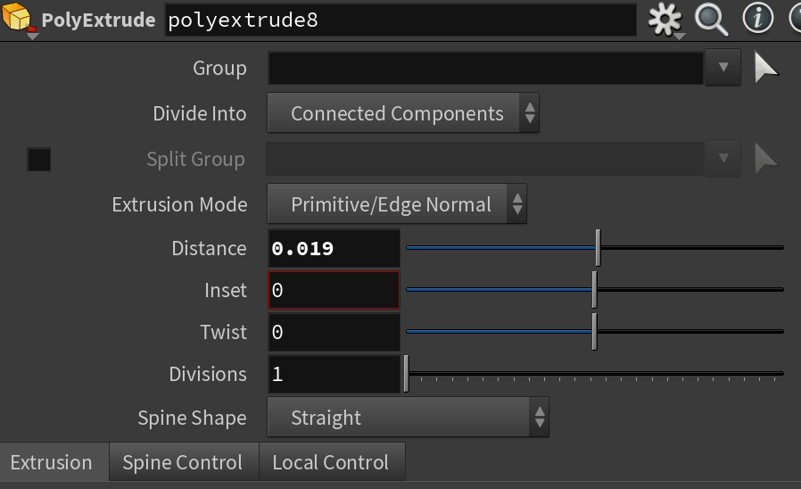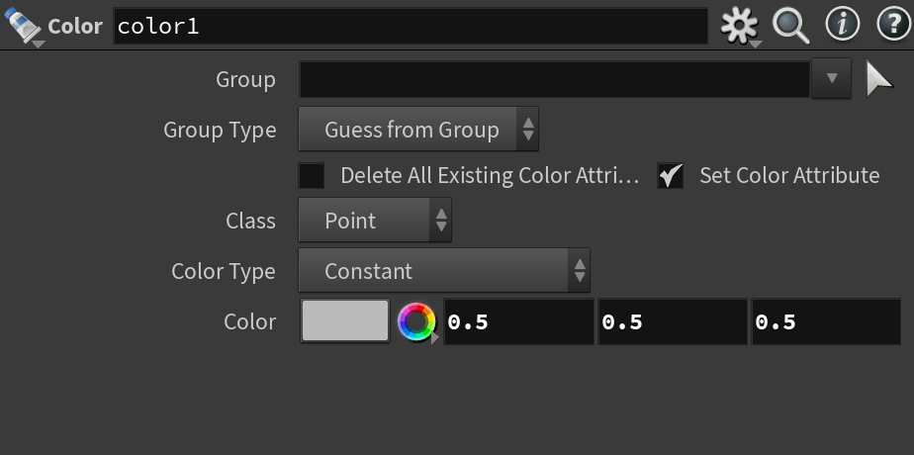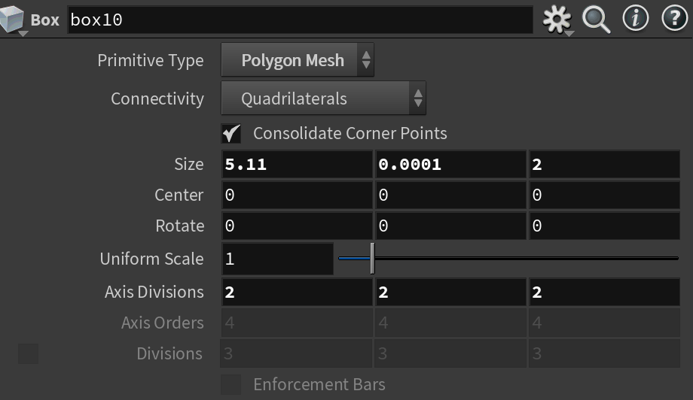Now I have created a road as a box using box node(box10) and used polyextrude node(polyextrude8) for transformation with adding colors using color node(color1) and transformed with transform node(transform12). Below is the parameter pane of all the four nodes:

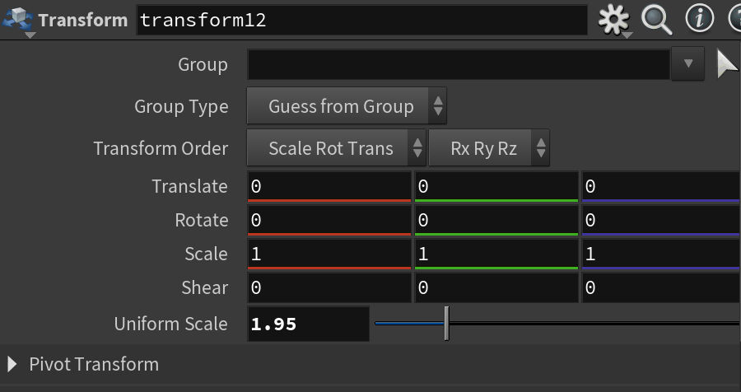Figure: Box node Figure: polyextrude Node

Figure: Color Node Figure: Transform Node

The output of the road looks like this:

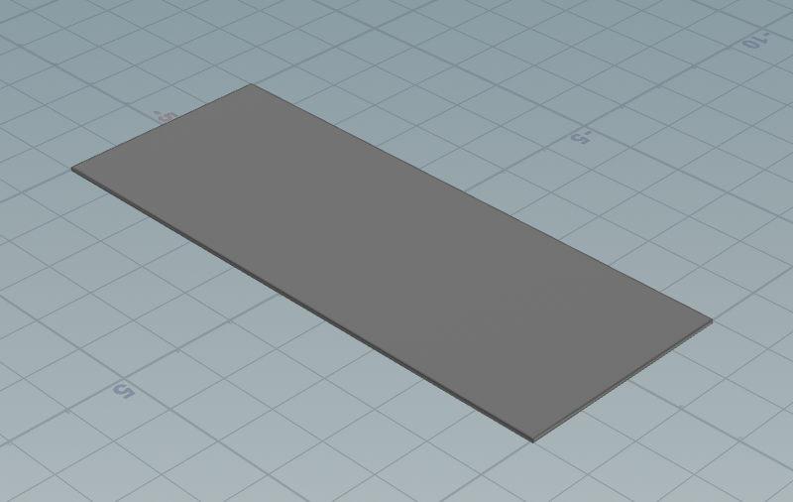

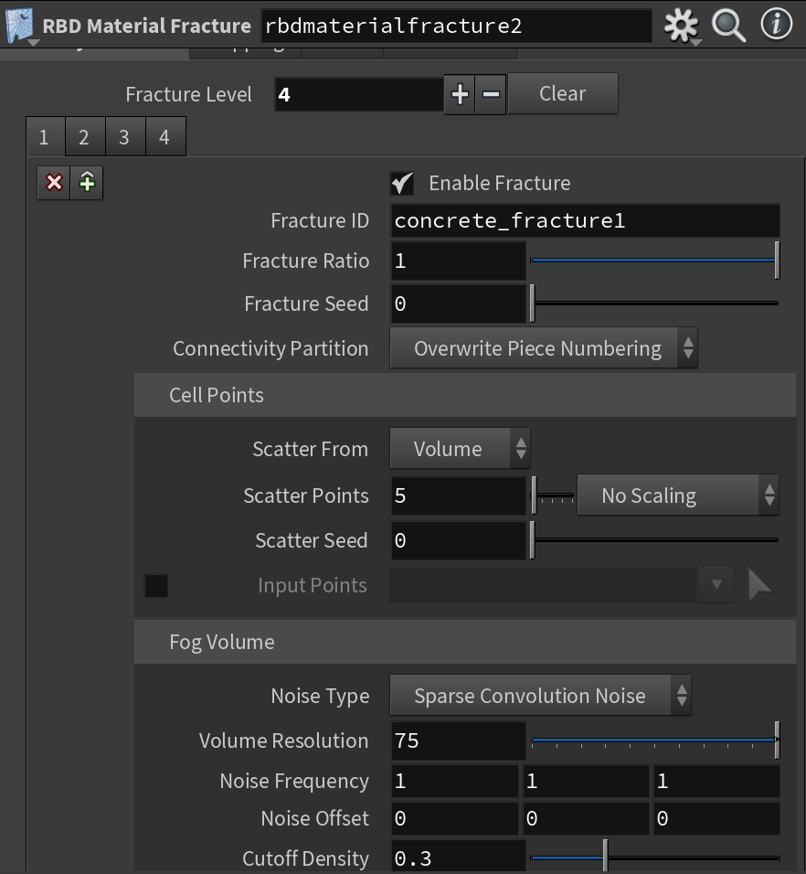I have used the rbdmaterialfracture for the road to crack with the switch node and merged the grid which I called as a base node , road divisions, and the road we created now with merge node.

Figure: rbdmaterialfracture Node

The result of rdbmaterialfracture node :

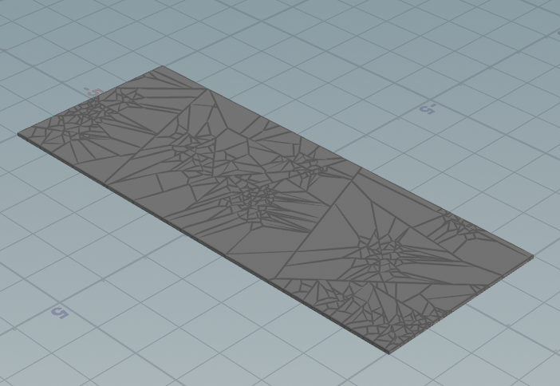

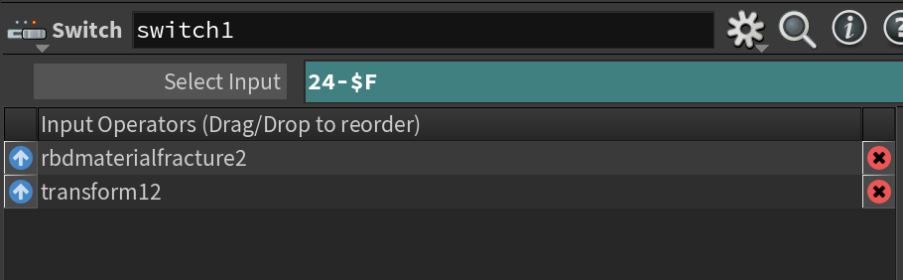After adding switch node and the merge node the parameter of switch parameter pane and result of the all three is below:

Figure: Switch Node

The result:

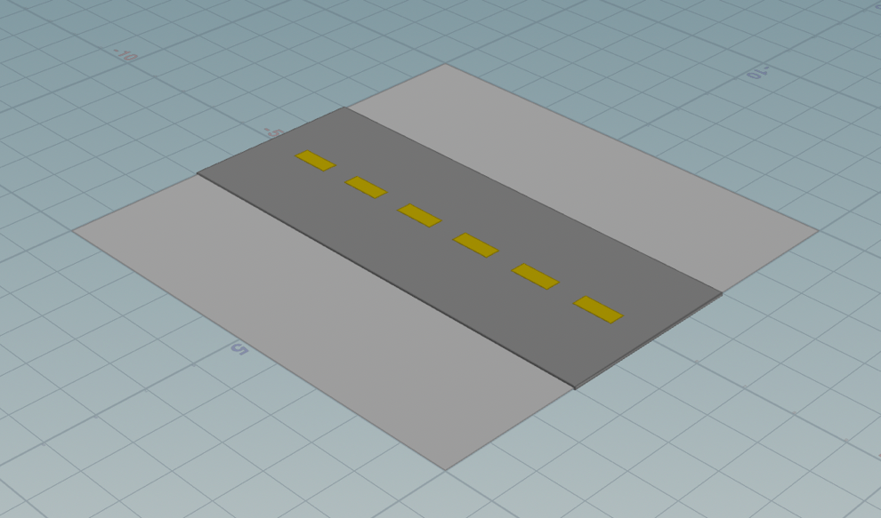

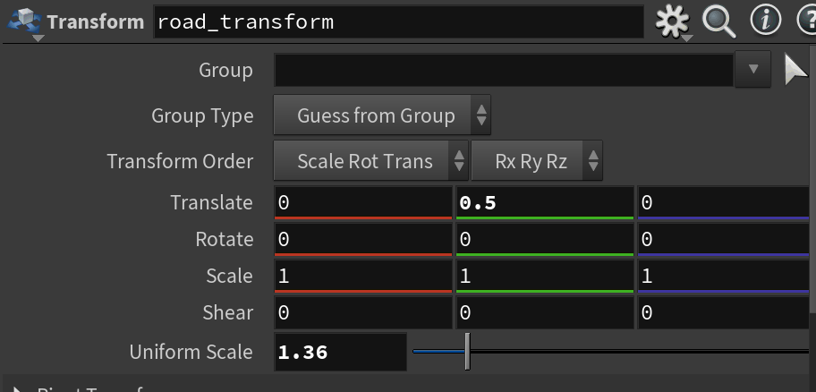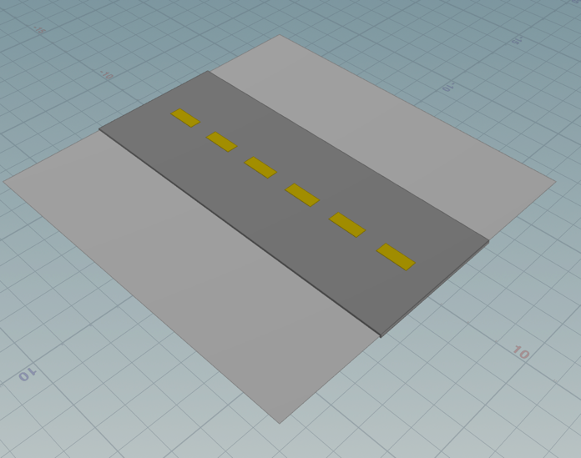I used transform node and transformed it with few changes in below of the parameter pane:

Figure: road_transform Firgure: Transformed Output

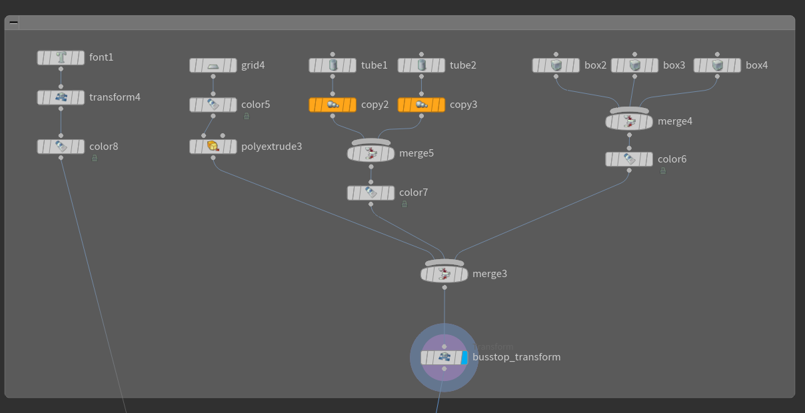Now I created a busstop using different nodes and below is the outline of the nodes used in creation:

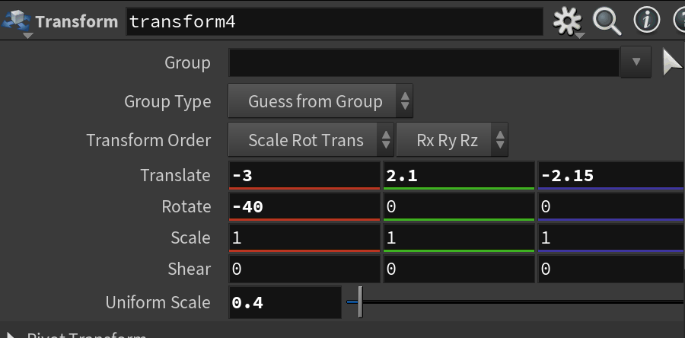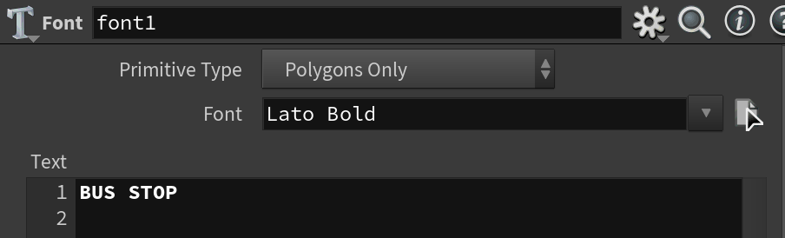I created font of the busstop using font node and transformed it for styling and added color using color node.

Figure: Text node/Font node Figure: Transform Node

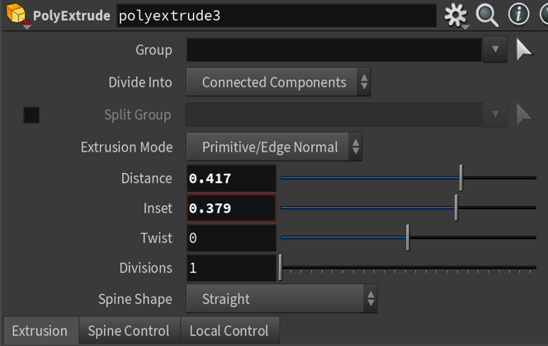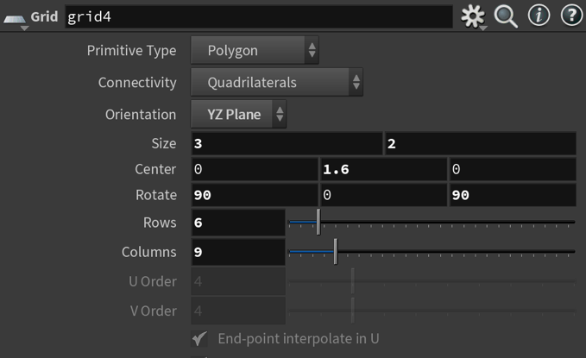Now I created a base for the shed of the bus stop using grid node with adding color to it using color node and transformed it by using polyextrude node with below modifications in parameter panes:

Figure: Grid Node Figure: Polyextrude

The below is the result of the top shed for bus stop :

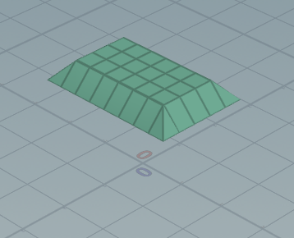

Add the polyextrude node to the merge node.

Now I have created a polls for bus stop using the tube node on left and right and used copy node for creating more two and at last merge them and colored with color node and added to the merge node of bus stop grid.

Below are the changes of the parameter panes :

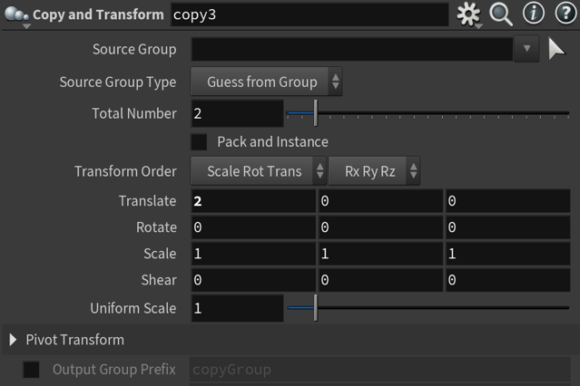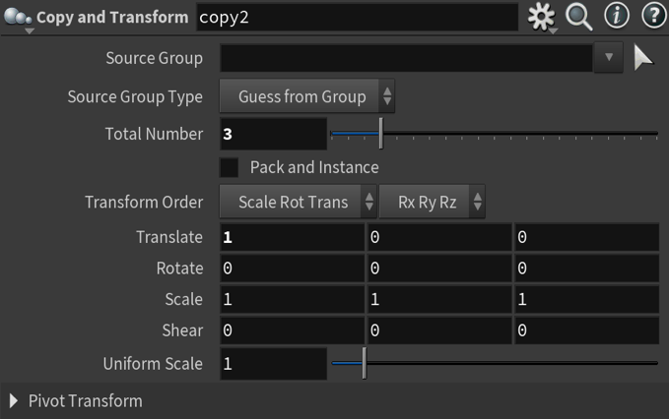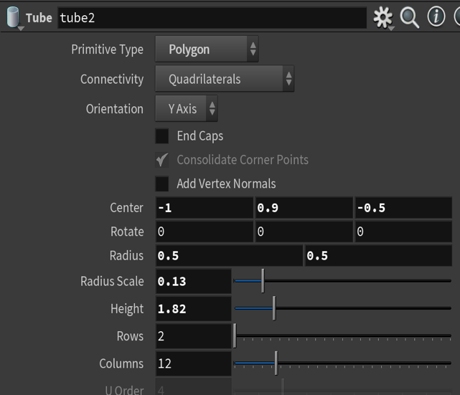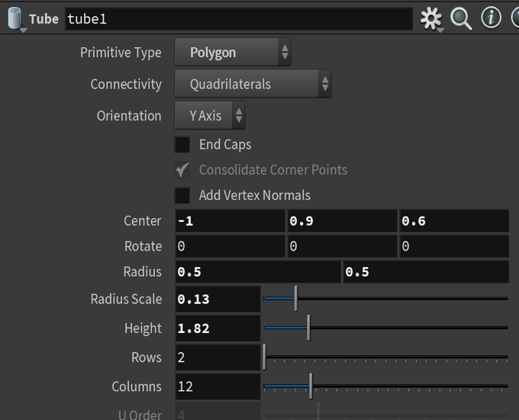Figure: Tube Node1 Figure: Tube Node2

Figure: Copy and Transform Node Figure: Copy and Transform Node

The below is the result of the polls:

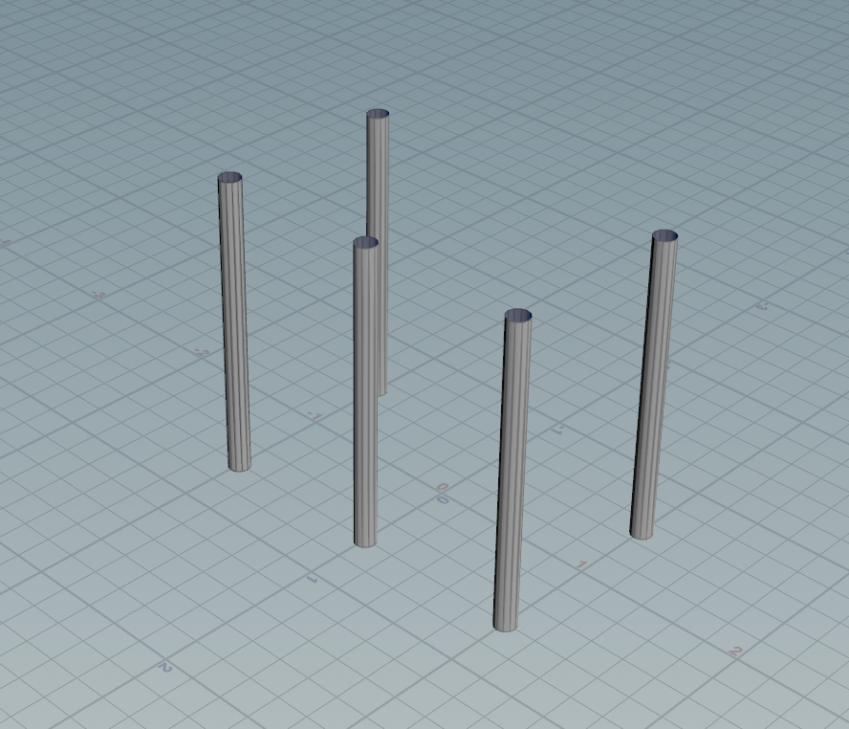

I have created a box like shape for these polls using box nodes on all three sides to cover the bus stop and used merge node and colored it for making it look good and in last I megered with the meger node of polls.

Below are the Parameter panes of the boxes :

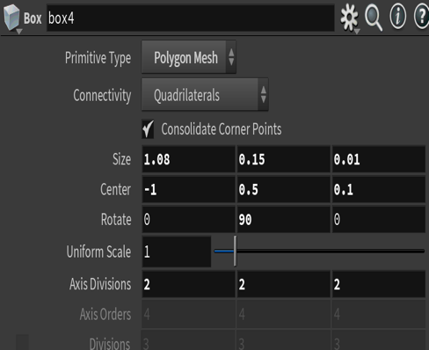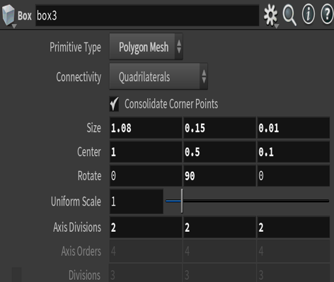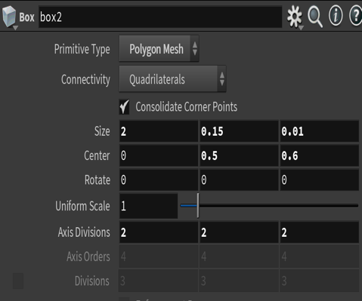Figure: Box Node Figure: Box Node-2 Figure: Box node-3

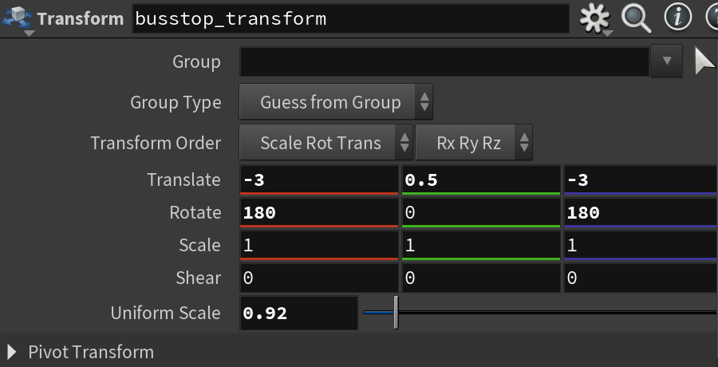For the Final result of bus stop I used transform node for the merge node which is created and connected with the top of the shed grid of bus stop , polls of bus stop and the sides of it. The Parameter pane of transform node is below:

Figure: Busstop_transform Node

The below is the final output of the bus stop:

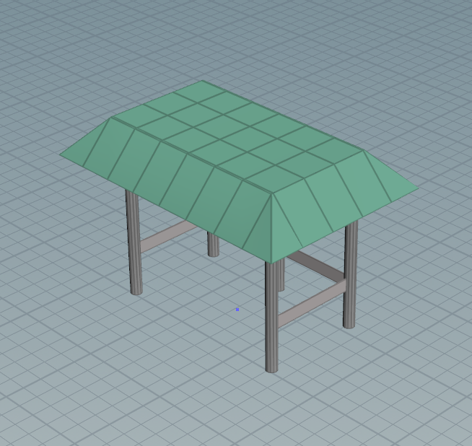

Now lets create a Building with the grid node with polyextrude for editing and transformation I used transform node and polyextrude again with transform node output is being extruded.

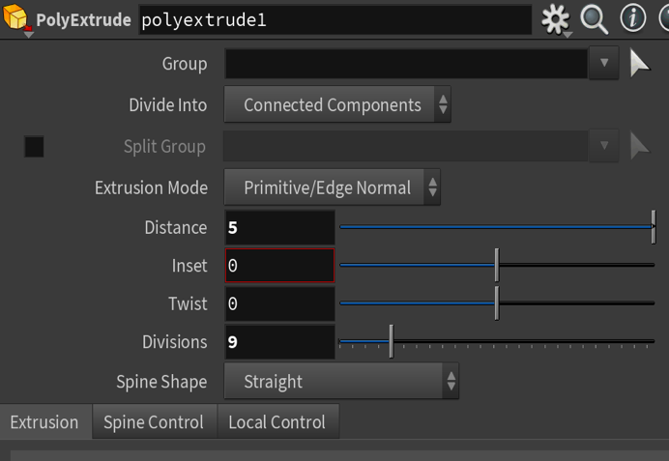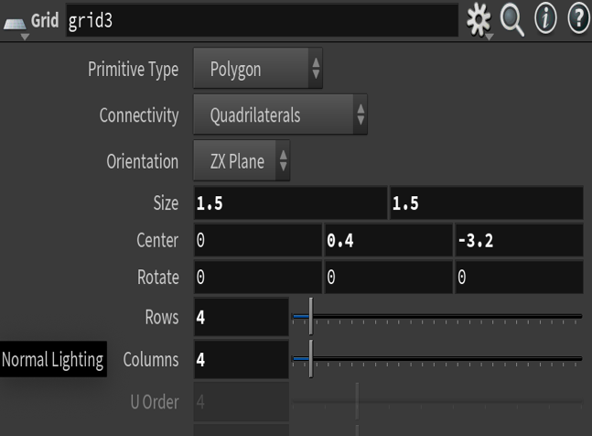Below are the parameter panes of the above discussed nodes:

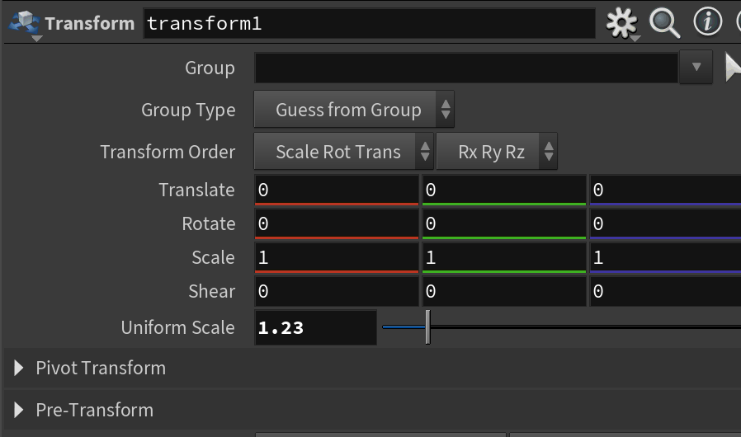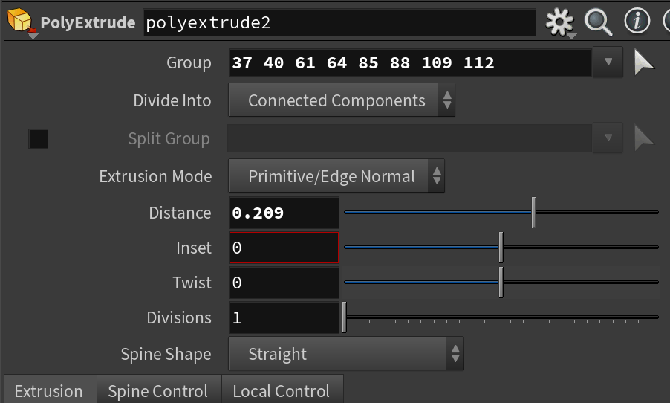Figure: Grid Node Figure: Polyextrude

Figure: Transform Node Figure: Polyextrude

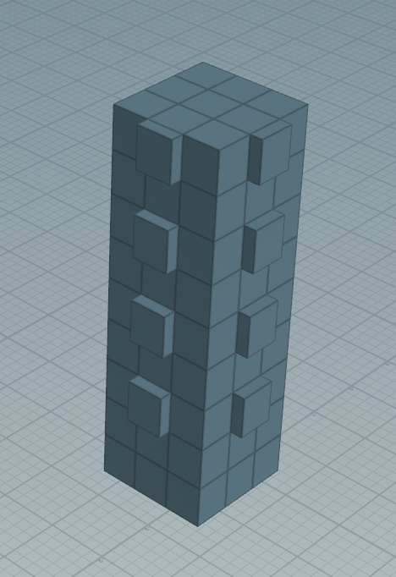The result of it is see below with the colored building with color node:

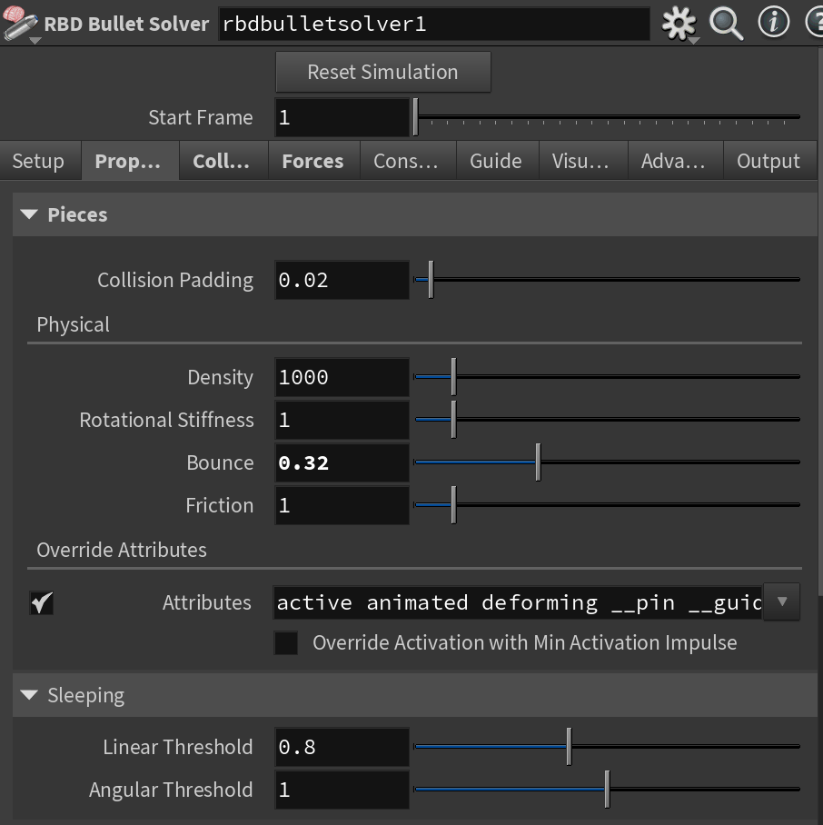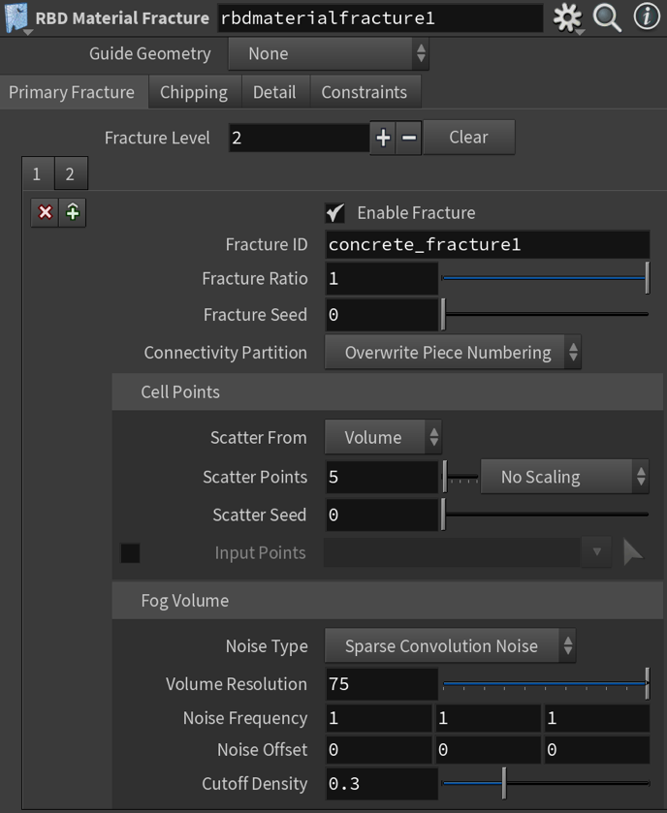I have added the rbdmaterialfracture and grid for it to stand on the ground and connected both with the rbdbulletsolver. Below are the parameter panes of these nodes:

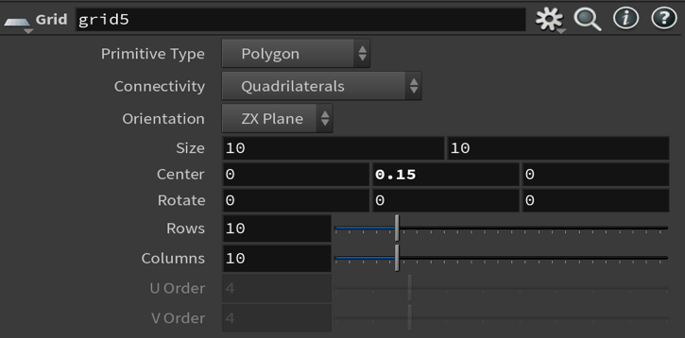Figures: rbdmaterialfracture1 node , rbdbulletsolver1 node, Grid Node.

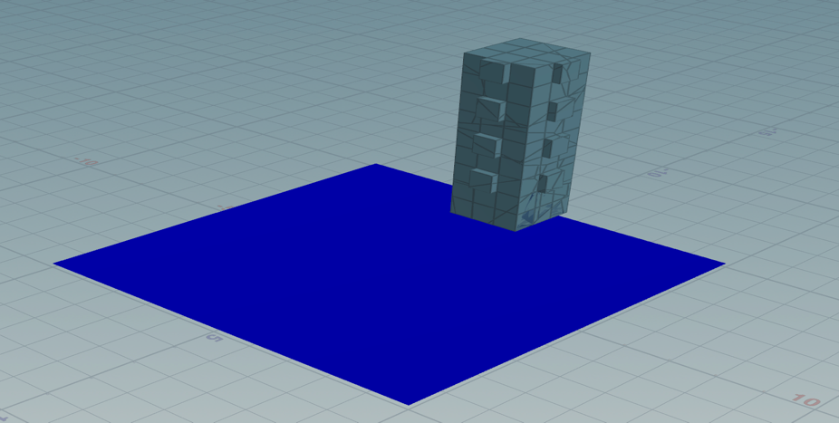The output of the Building after this can look like below:

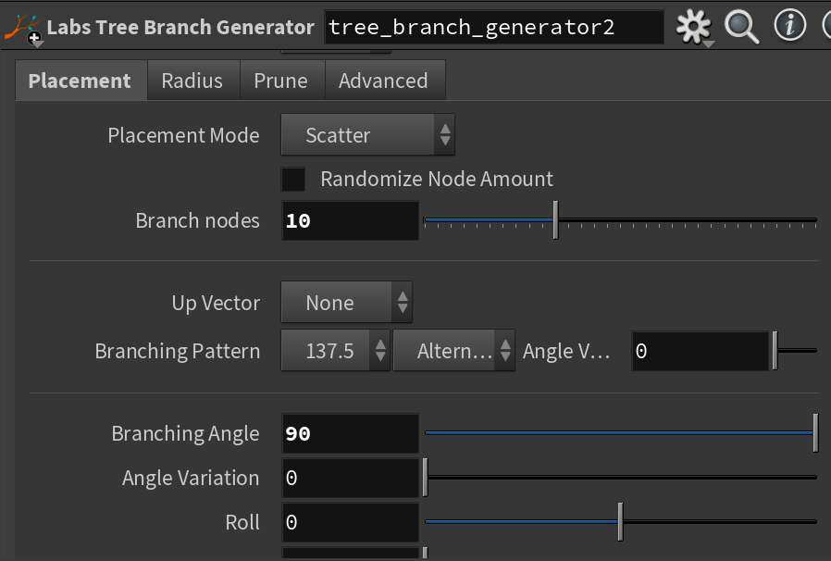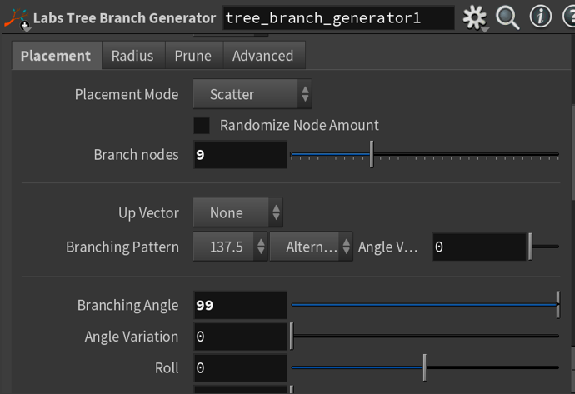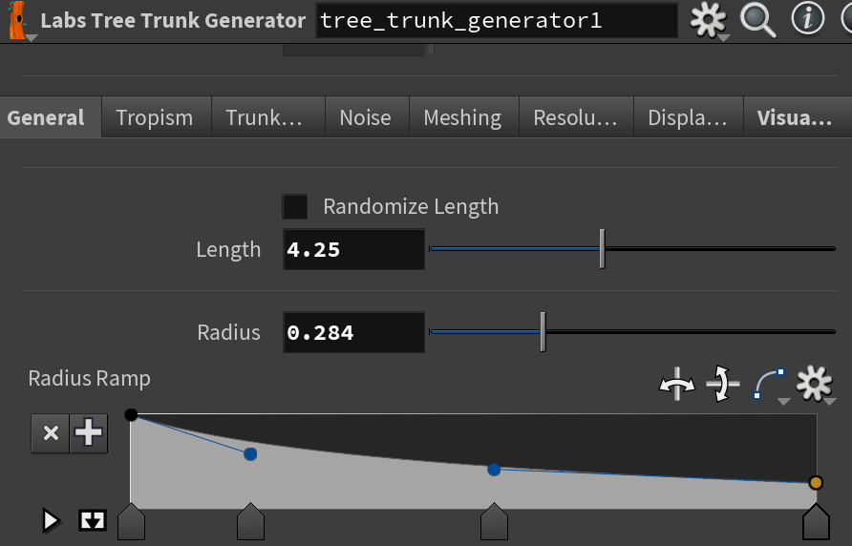I have created a tree near bus stop with the node called tree_trunk_generator1 and tree_branch_generator1 with these nodes I have created a stem and added the branches with three branch nodes. The parameter panes can be seen below :

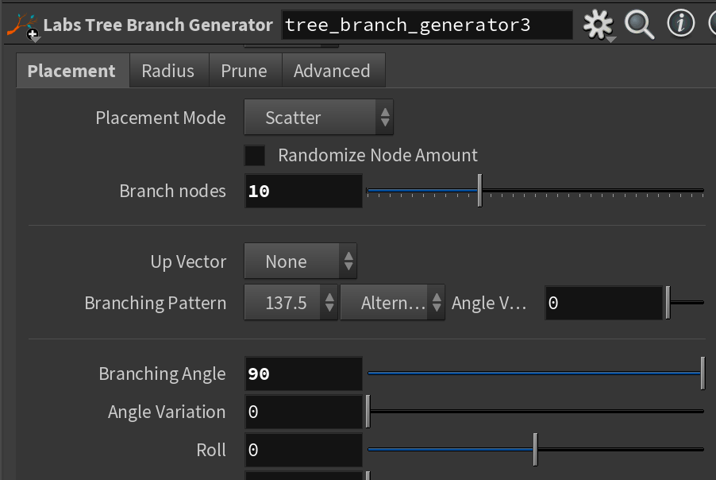Figure: tree_trunk_generator1 node Figure: tree_branch_generator1 Node

Figure: tree_branch_generator2 Node Figure: tree_branch_generator3 Node

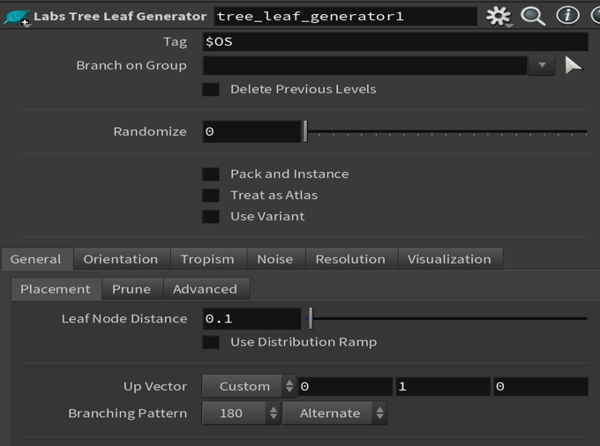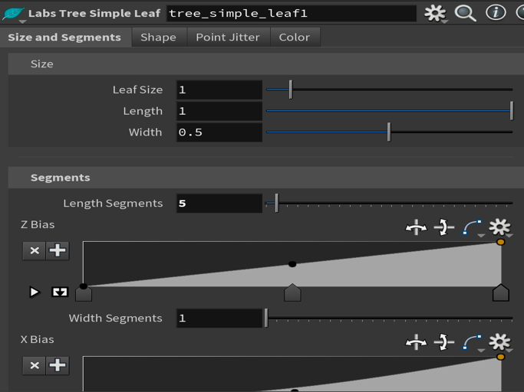I added color node and colored it with stem color and added the leafs with the node called tree_simple_leaf1 and generated them with the node called tree_leaf_generator1. Below are the parameter panes for both of them :

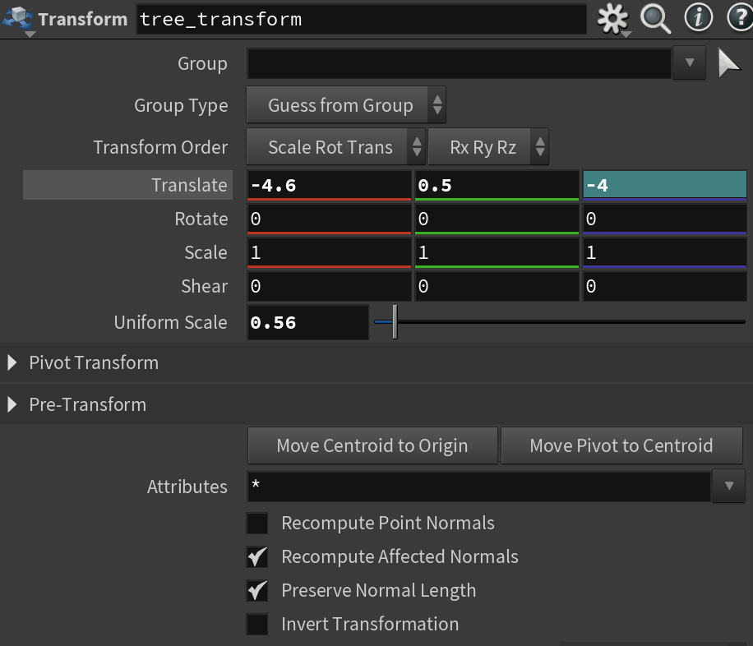The output of the tree looks after merging all the above nodes and transformed the merge node with below parameters :

Figure: Tree_Transform Node

The output of the tree looks like this:

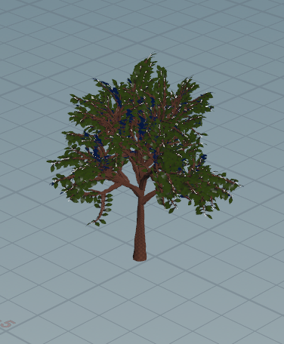

Now I created the Street lights using the tube node one as the pole of the light with the bend node and color node to make a u shaped pole and the light is created with the tube node by using polyextrude node I edited it forther for required shape and added the color to it.

Below are the parameter panes for pole:

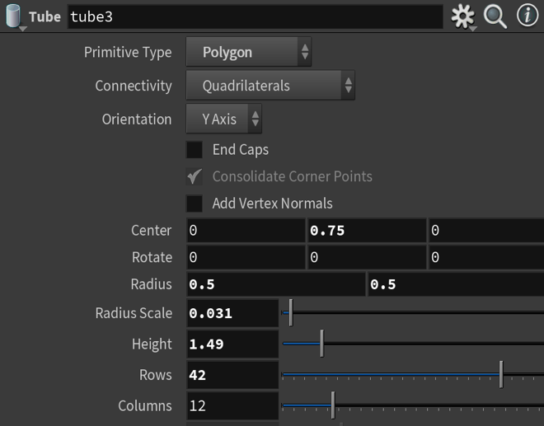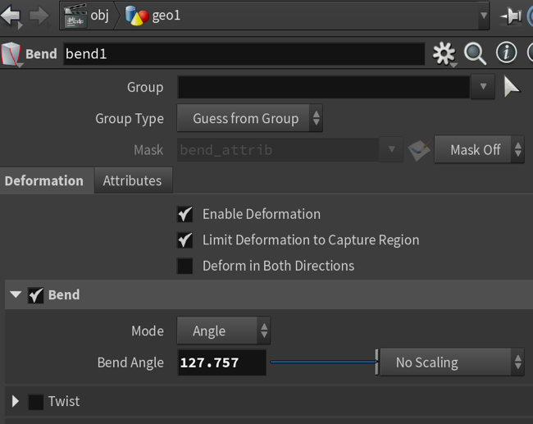Figure: tube Node Figure: Bend Node

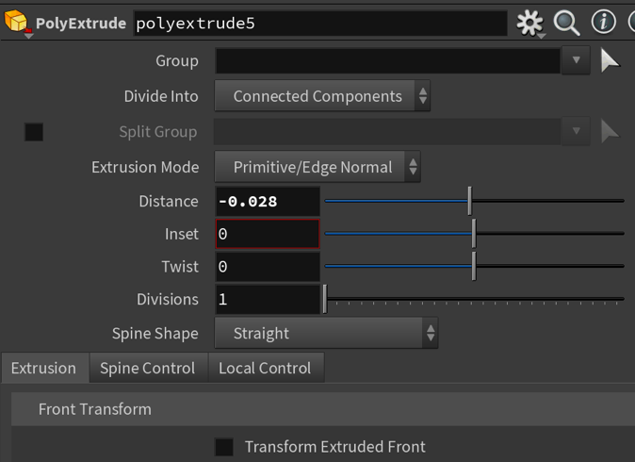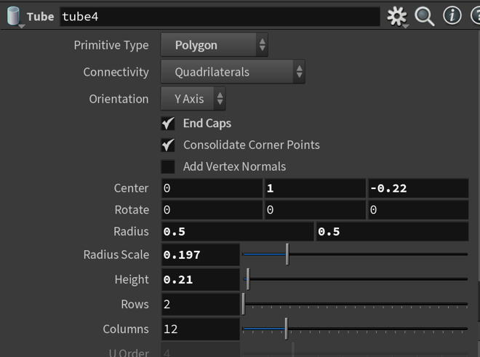Parameter panes for the Light for poles and added the color node :

Figure: Tube Node Figure: Polyextrude Node

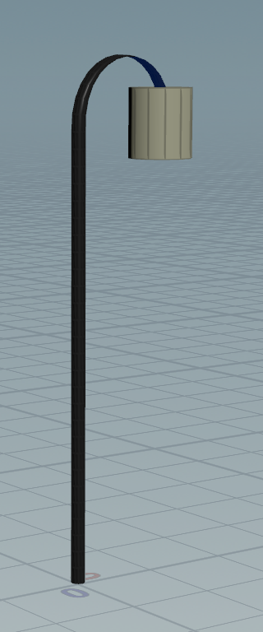After using merge to merge the pole and light we get the below output:

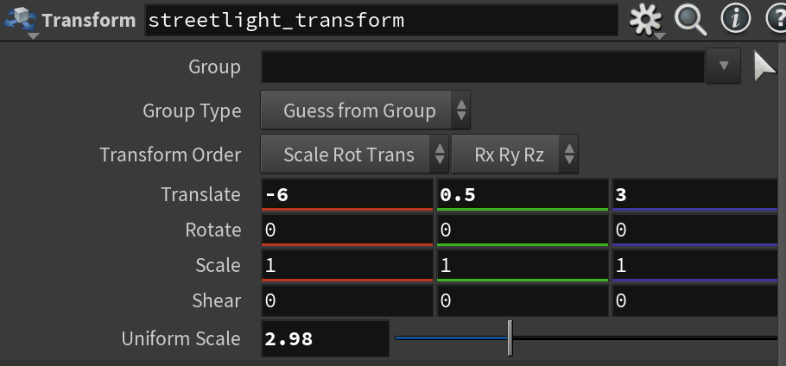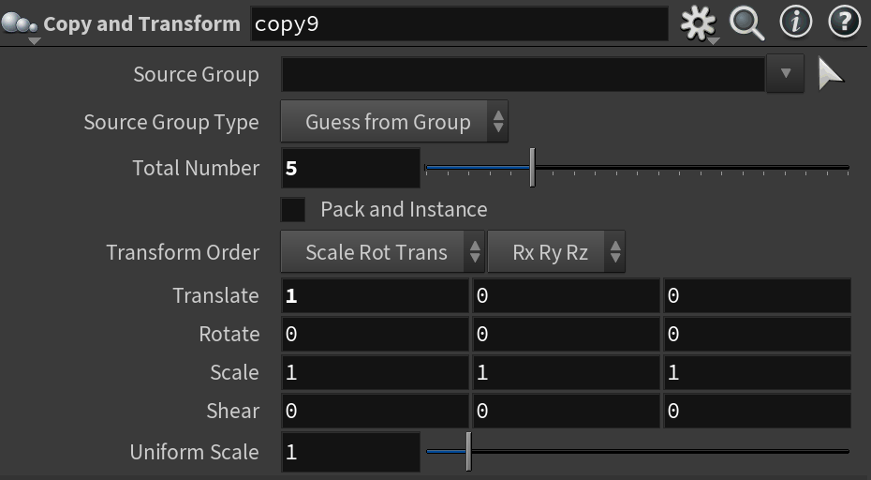I have created the multiple street lights using copy to points node and transformed them for them to align properly. Below are the parameter panes of those:

Figure: Copy and Transform Node Figure: Transform Node of Street lights

The Final output of street lights after transformation looks like:

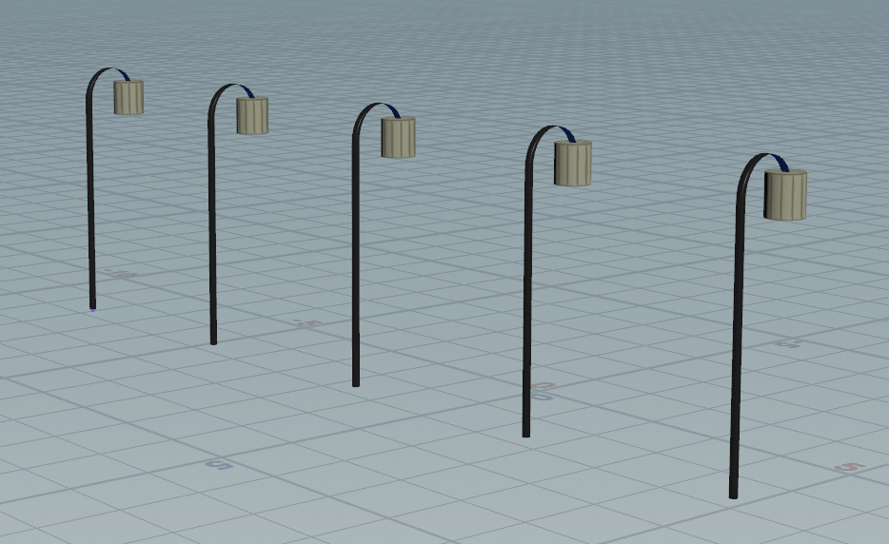

Next we are gonna create a grass with the fence kind using a base with grid node and colored it using color node as green and for the fence kind brick I used box node and created multiple using copy to transform node of about 5 bricks and added the color to it and merged the base and the bricks using merge node .

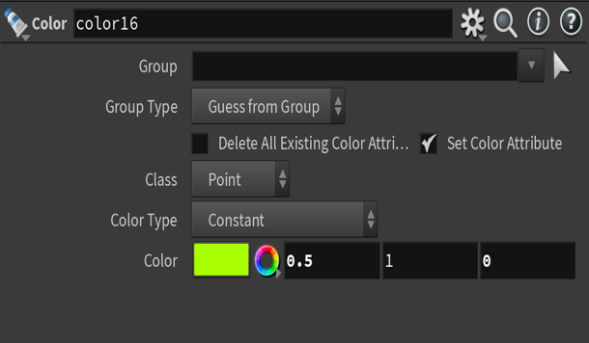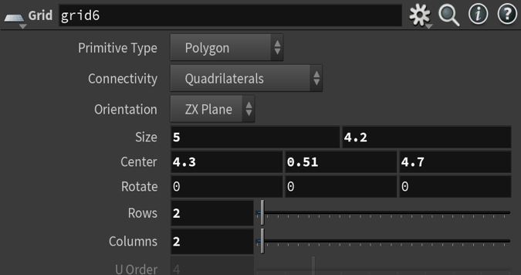Below are the Parameter panes of the grid:

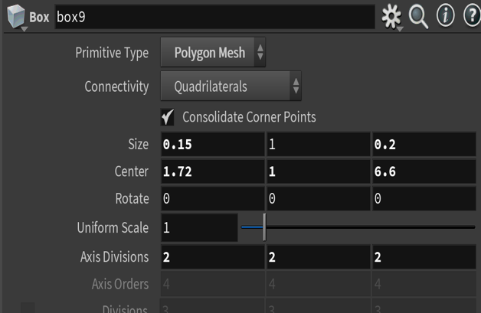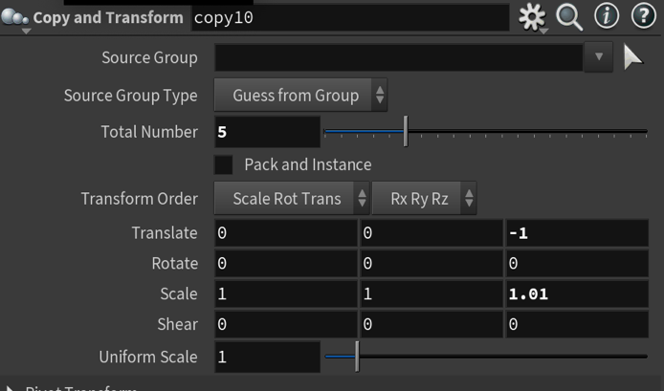Below are the parameter panes of the bricks:

Figure: Box Node Figure: copy and transform node

The Complete garden looks like :

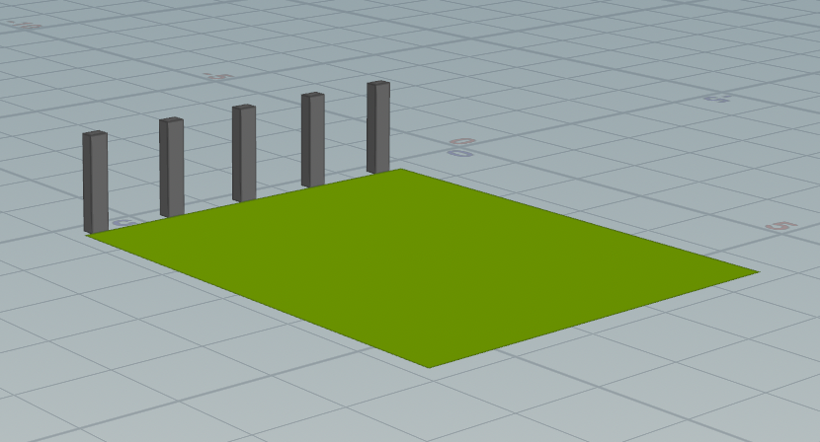

I have created a water fountain by using tube node, polyextrude node for the outer surface and for water to spill like foundation I used circle node, polyextrude, popnet node, and transform node.

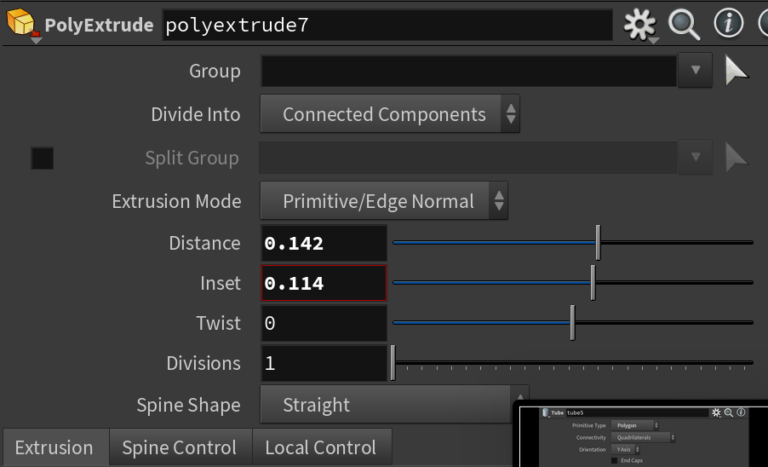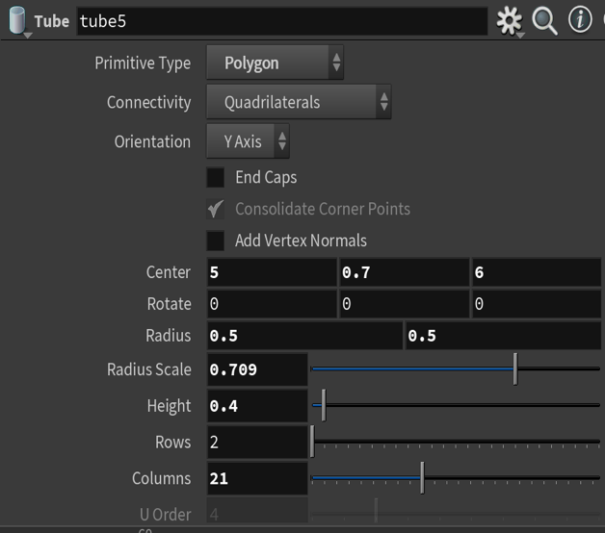Popnet is used for the animation of the water bubles like circle with circle node and they are positioned with transform node. Below are the parameters of the outer surface:

Figure: Tube Node Figure: Polyextrude Node

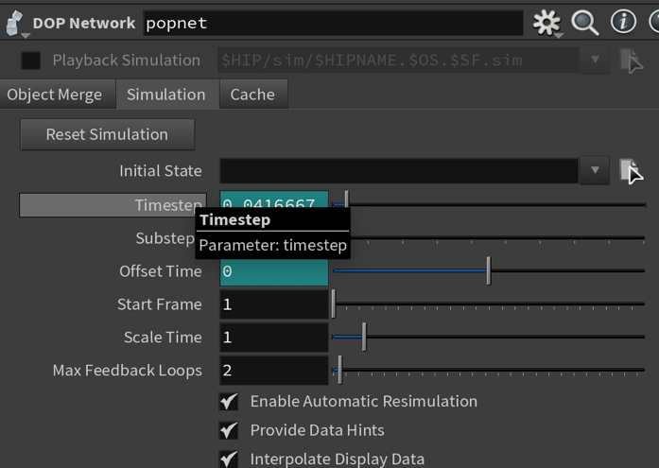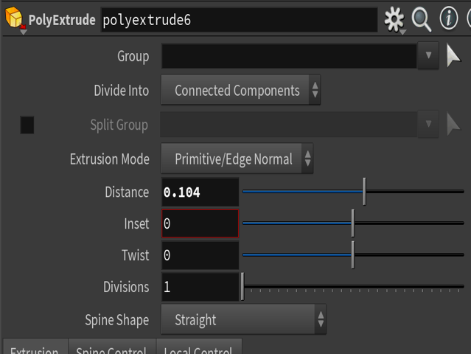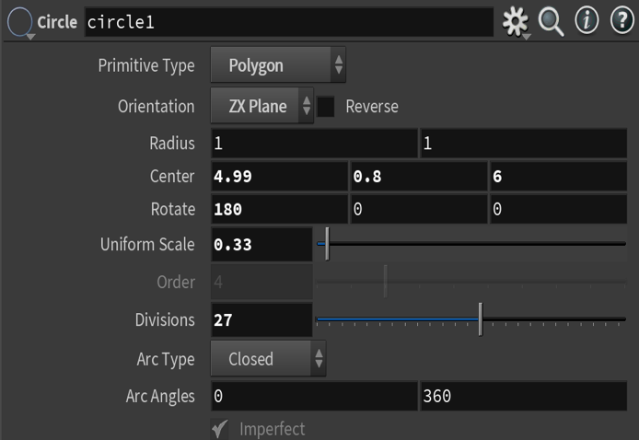Below are the Parameter panes of the water inside :

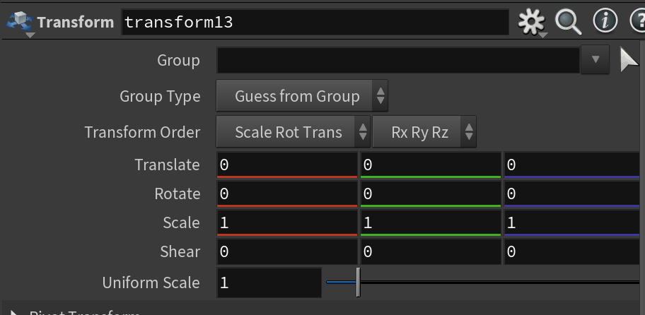Figure: Circle node Figure: Polyextrude Node

Figure: Popnet Node Figure: transform Node

After merging them I used transform node for positioning it and the final output looks like:

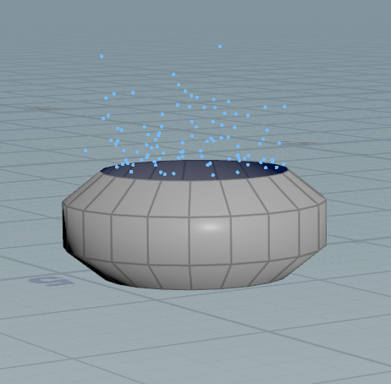

I have created a small car with two main nodes , one for body surface I used box node and for tires I used torus node. The car to get into proper shape i used polyextrude node , transform node and color node for surface body and tires. I finally used merge node for connecting all together and transformed it for proper shape and in last I used switch node for the car to divert when the road is cracked .

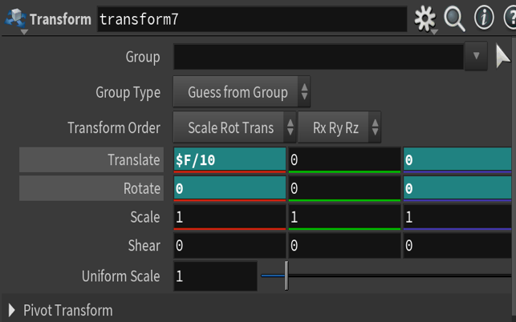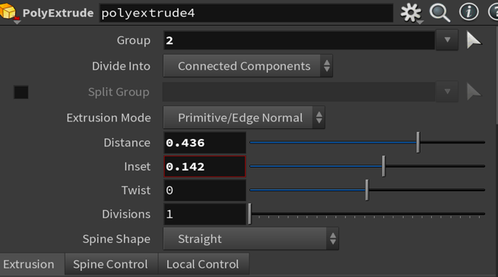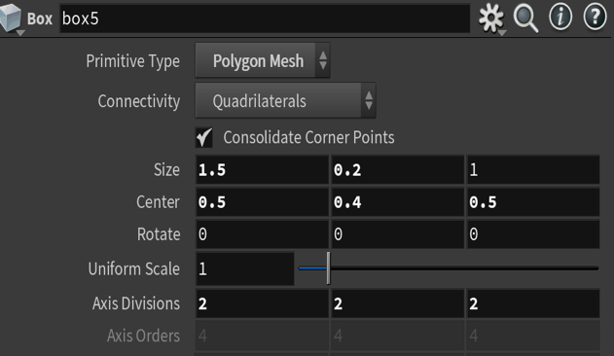For Surface body below are the parameter panes of the nodes:

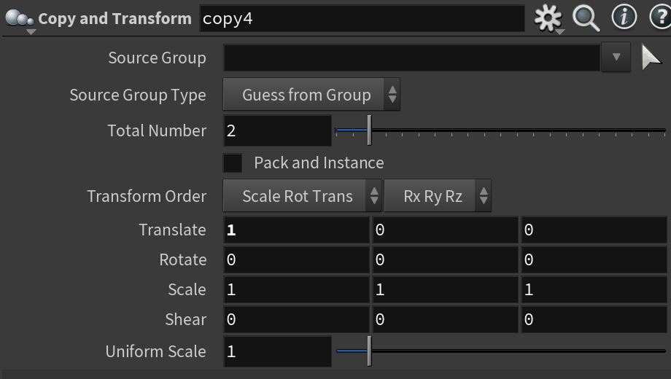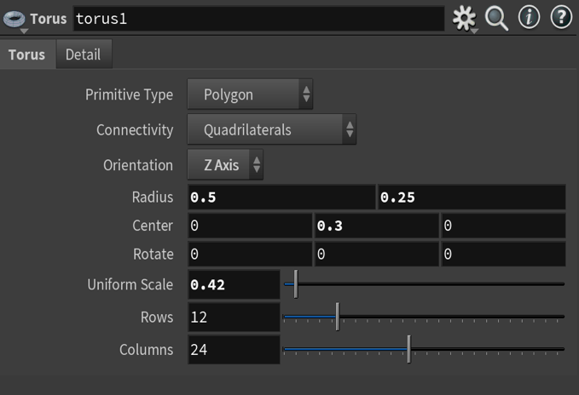For the tires below are parameters of the discussed nodes:

Figure: Torus Node Figure: Copy and transform node

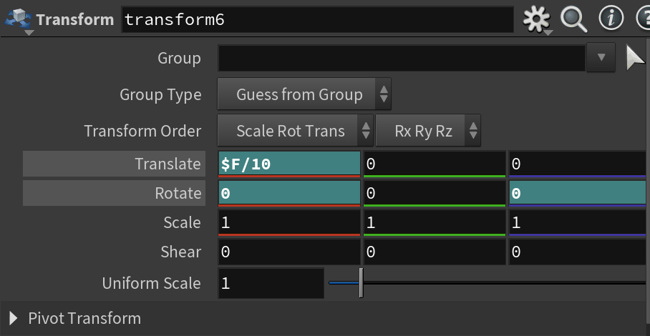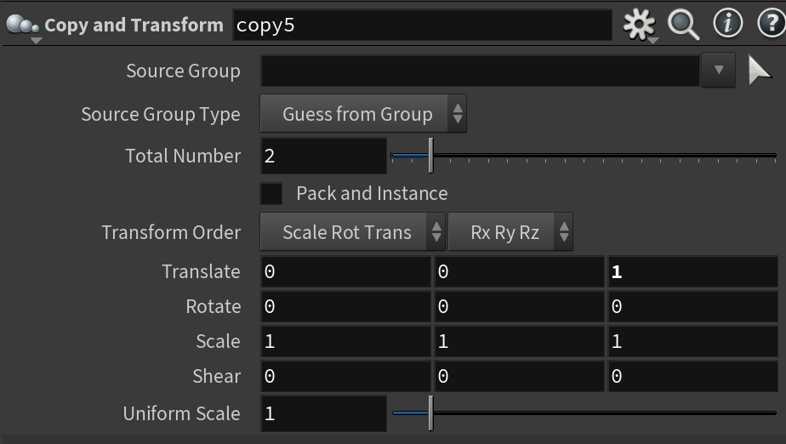

Figure: Copy and transform node Figure: Transform Node

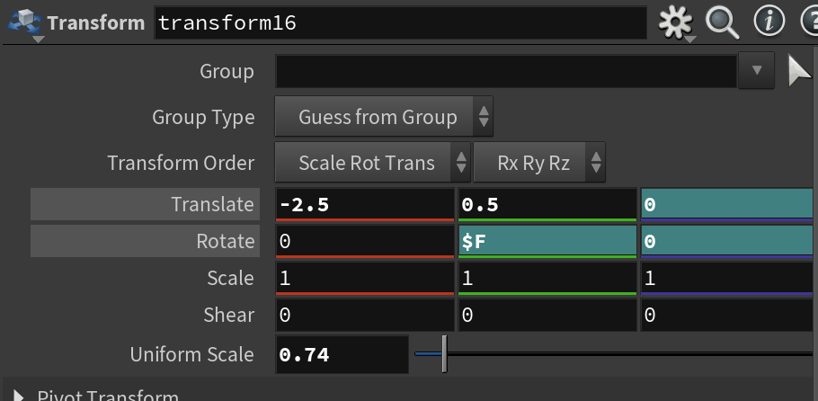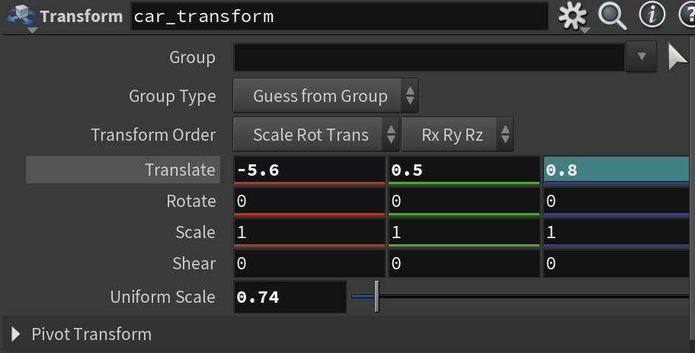The below are the transformation parameter panes after merging the body and tires:

Figure: transform node Figure: Transform Node

The final output of the car looks like below:

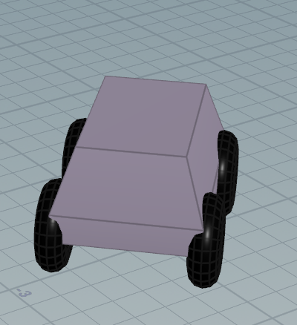

I have created one more vehicle called bus with the same as car for surface body I have used box node and for tires I have used torus node and for proper position and shapes I used transform node, and for copying the tires and windows I used the copy to transform node.

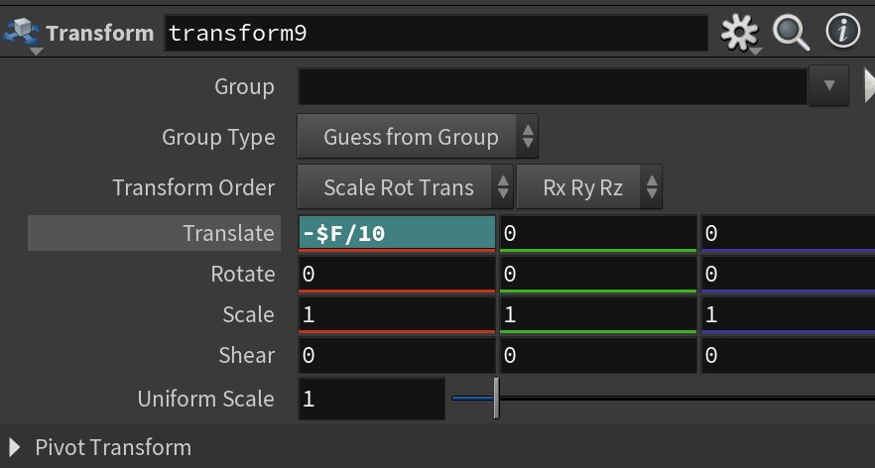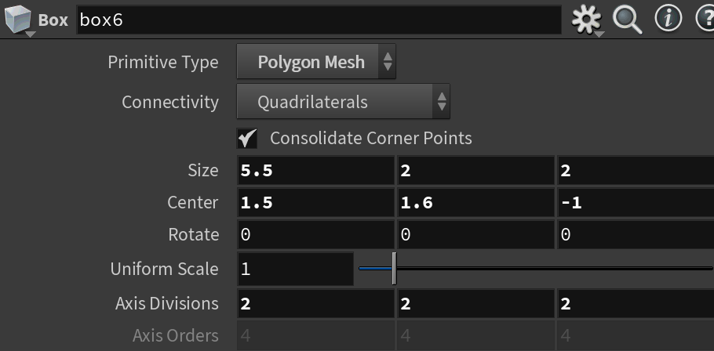Below are the parameter pane for surface body:

Figure: Box Node Figure: Transform Node

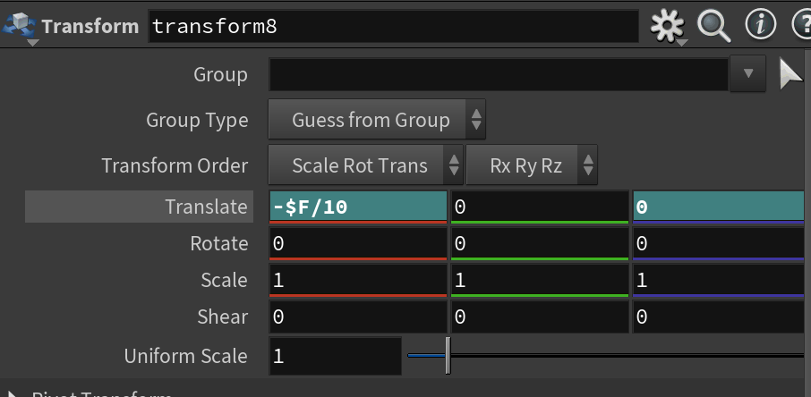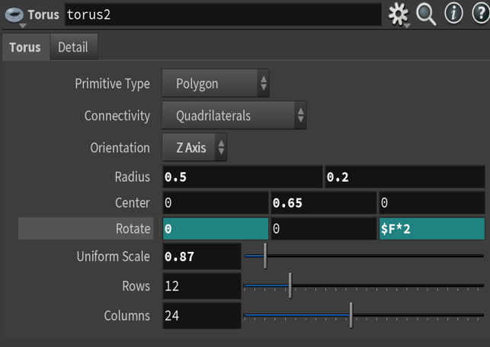For the tires below are the parameter panes:

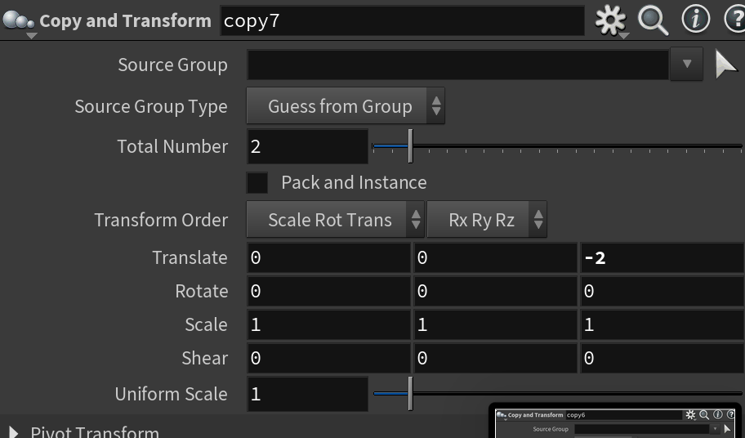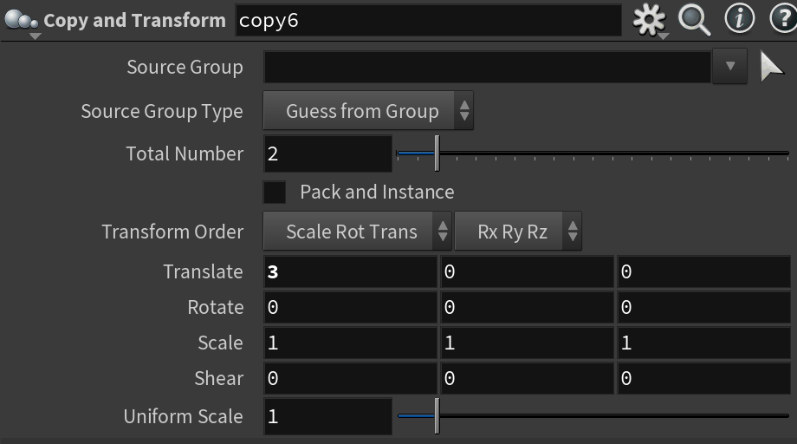Figure: Torus Node Figure: Transform Node

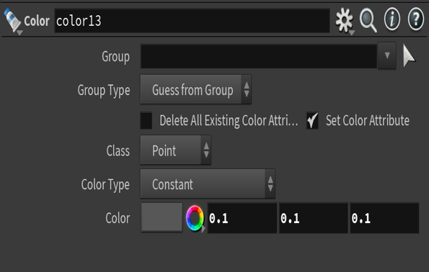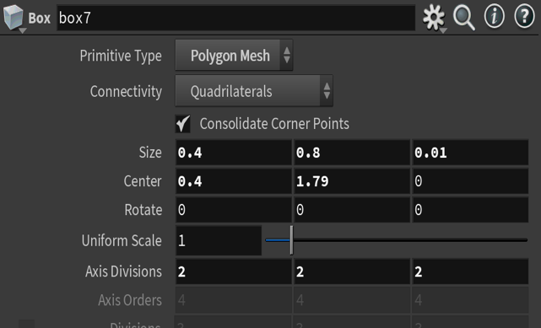For windows below are the parameter panes:

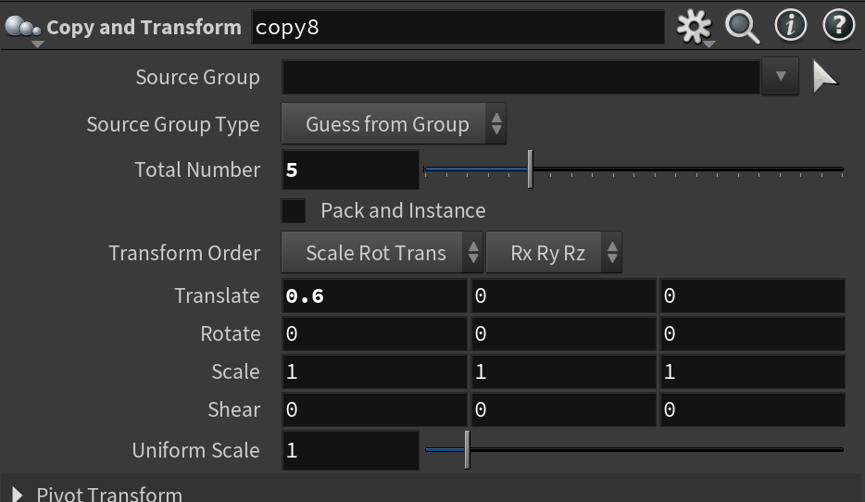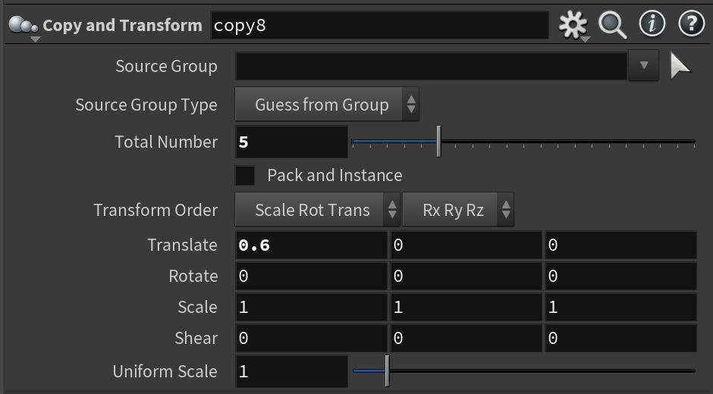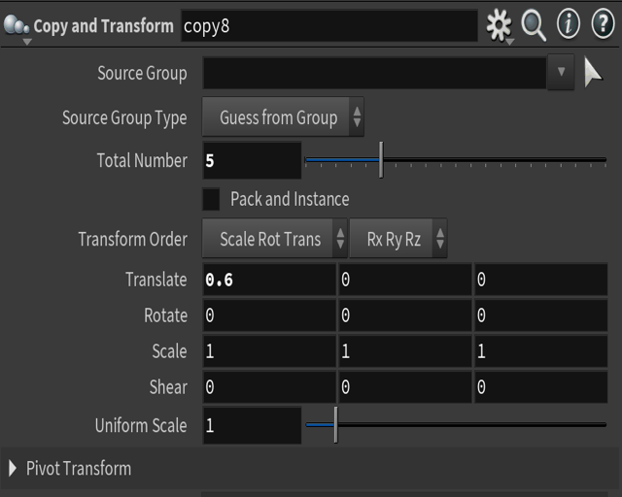Figure: Box Node Figure: color Node

Figure: Copy and transform node

After merging them I used transform nodes for them to position correctly and below are the parameter panes of them:

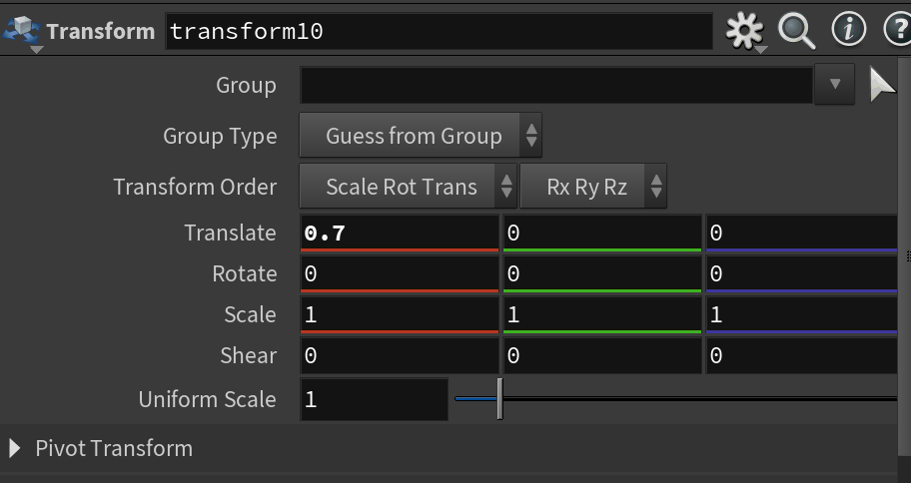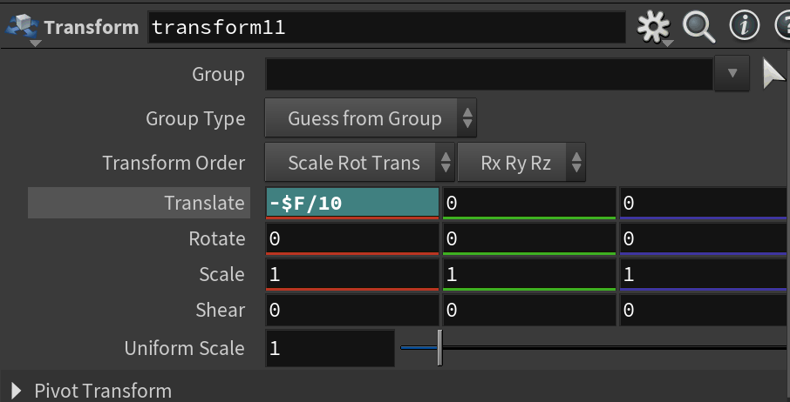Figure: Transform Node Figure: transform node

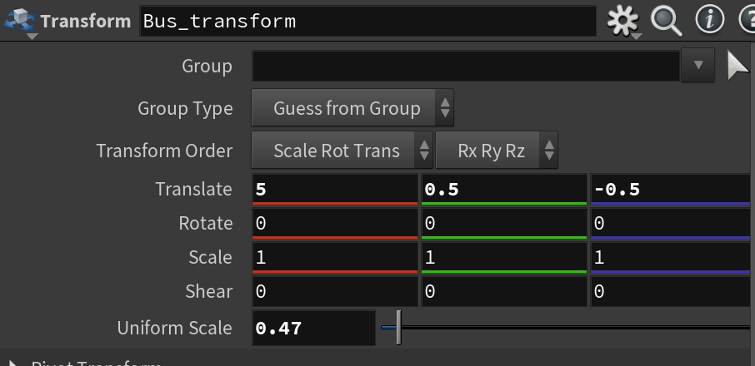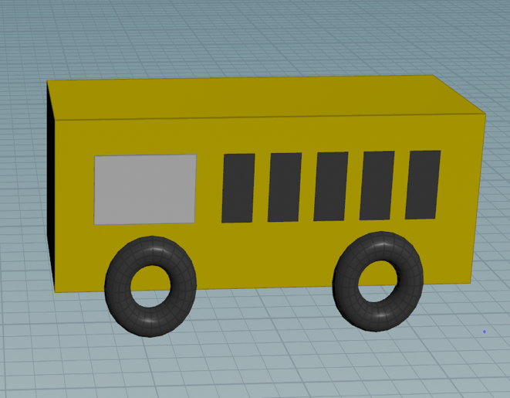Now I created a merge node, and I connected all the parts of bus i.e tires body and windows and then I transformed it again for the final one. Below are the transform node parameter pane and the output of the bus.

Figure: Final Bus Figure: Bus Transform Node

In the final I created a Merge node and added all the nodes of the bus, car, tree, building, garden, road, streetlights, and bus stop to see the final output. Now play the animation button you will see the building collapsed, road cracked and the car moves out of track as a earthquake occurs.

**References:**

[Tree](https://youtu.be/IZ5uJYg0ELM?si=mL_EuUxG9uXIzAQh) : https://youtu.be/IZ5uJYg0ELM?si=mL_EuUxG9uXIzAQh